**Exercise: Optimizing a dashboard**

**Introduction**

So far, you have gained a thorough understanding about dashboard design and the significance of data mobility and accessibility. Microsoft Power BI is a complete business intelligence ecosystem that provides the tools and techniques to design user-centric dashboards and how to optimize them to join the digitalization wave and keep informed on real-time.

In this exercise, you will be reviewing, publishing, creating, and optimizing a Power BI dashboard of Adventure Works products for mobile devices. Adventure Works has a diverse portfolio of its products, and the inventory management team needs to have a dashboard showing the sale of product categories, subcategories, and top and least selling products to manage the regional inventory levels.

**Scenario**

Adventure Works has an extensive product catalog spanning thousands of items across various product categories and subcategories. Adventure Works’ chief product officer (CPO) is keen to optimize product dashboards to drive important strategic decisions about least selling products, enhance customer experience, and boost sales across various regions. The CPO needs a unified view of the product data that is accessible anytime, anywhere, and on various devices. To complete this task, you will need to go through each step of creating and optimizing a dashboard for cellular devices. By completing this exercise, you will demonstrate your ability to:

* Review existing reports on Power BI desktop and publish them to Power BI service.
* Create a product dashboard in Power BI service and optimize for mobile devices.
* Rearrange and resize the tiles for phone screen and unpin any unnecessary tiles.

Follow the exercise steps to optimize the report for mobile layout and ensure the visual elements in the mobile canvas are properly positioned and scaled to eliminate any visual clutter.

**Step 1: Download the Power BI project file.**

* Download and save the Power BI project *Adventure Works Optimizing a dashboard.pbix.* The report contains two report pages; **Products** and **Categories.**

[Adventure Works Optimizing a dashboard](https://d3c33hcgiwev3.cloudfront.net/sff4v1iWTlqKN_WJABhH4g_f456fca7b5ea40b4b57e240a604170a1_Adventure-Works-Optimizing-a-dashboard.pbix?Expires=1712275200&Signature=KJURJ--WD1CVqnYQ5oZplUKWyckeSBLSbC~AkOcs03NlQy-Kit~sHN3DQ2zJd1eotYMMiJBCgaOuo0~PpMPpCq2yHjDR2jr7Svv3ZQChbBDYyo-3jMVQ3AGLPMo0mL9SCkpsjxkxAk6lD0SxIcDvBK~T6uipBVBRM-9Wfp8YxG0_&Key-Pair-Id=APKAJLTNE6QMUY6HBC5A" \t "_blank)

[PBIX File](https://d3c33hcgiwev3.cloudfront.net/sff4v1iWTlqKN_WJABhH4g_f456fca7b5ea40b4b57e240a604170a1_Adventure-Works-Optimizing-a-dashboard.pbix?Expires=1712275200&Signature=KJURJ--WD1CVqnYQ5oZplUKWyckeSBLSbC~AkOcs03NlQy-Kit~sHN3DQ2zJd1eotYMMiJBCgaOuo0~PpMPpCq2yHjDR2jr7Svv3ZQChbBDYyo-3jMVQ3AGLPMo0mL9SCkpsjxkxAk6lD0SxIcDvBK~T6uipBVBRM-9Wfp8YxG0_&Key-Pair-Id=APKAJLTNE6QMUY6HBC5A" \t "_blank)

**Step 2: Review the report pages of the project.**

* Next in this task is to review the current layout and design. This includes analyzing the sequence of visuals to be displayed on the dashboard and mobile version based on the importance of information. Identify the visual element that is not suitable for mobile devices.

**Step 3: Publish the report to Power BI service and create a dashboard.**

1. Publish your report on the Power BI service.
2. Log in to the Power BI service on your web browser.
3. Create a new dashboard named **Product Sales** in the workspace.
4. Pin all tiles from the product page of the Power BI report to the dashboard.
5. Pin all tiles from the categories page of the Power BI report to the **Product Sales** dashboard.

**Tip:** You can publish your report by selecting the **Publish** button from the **Home** tab of Power BI.

**Tip:** To create a new dashboard, you can select **New** from the **My workspace** interface in Power BI service.

**Step 4 :Optimize the dashboard for mobile devices.**

1. Optimize the **Product Sales** dashboard for mobile devices.
2. Arrange the tiles in a logical sequence on the edit mobile layout pane of Power BI service.
3. Resize and reposition the visuals to create a coherent visual story.

**Tip:** You can **unpin all visuals** to start optimizing the mobile screen.

**Tip:** You can also use **Reset Tiles** to revert to the original state of dashboard.

**Step 5: Save the Power BI project.**

* Save your updated Power BI project to your local computer.

**Tip:** Make sure you select an appropriate project name and folder path for your project.

**Conclusion**

With these steps, you have successfully published a Microsoft Power BI report for Power BI service. You have created and optimized a dashboard for cellular devices to meet the needs of Adventure Works CPO.

**Exemplar: Optimizing a dashboard**

**Overview**

In the exercise *Optimizing a dashboard*, you put into practice your understanding of how to create and optimize a dashboard for a mobile device in Microsoft Power BI.

Your objective for this exercise was to complete the following tasks:

* Review the current layout and design of report pages.
* Publish the report to Power BI service and create a dashboard.
* Optimize the dashboard for mobile screen by resizing and repositioning tiles.

This reading provides a step-by-step guide for completing these tasks, accompanied by screenshots for easy comparison with your own copy.

You can also review the video [*Optimizing a dashboard for mobile phones*.](https://www.coursera.org/learn/creative-designing-in-power-bi/lecture/M4duD/optimize-a-dashboard-for-mobile-phones)

**Step 1: Download the Power BI project file.**

* Download and save the Power BI project *Adventure Works Optimizing a dashboard.pbix*

[Adventure Works Optimizing a dashboard](https://d3c33hcgiwev3.cloudfront.net/u_LI0seLQvuGLmoqHM2eww_6ff51775fe0b4e73a4a0fcc2d6356ea1_Adventure-Works-Optimizing-a-dashboard.pbix?Expires=1712361600&Signature=TB3YvjqCxdDI0-N9gTPTOM3ks49j-3OPUjuYt6r61Xb0KdmYVy0GHEUrvrBNLf9mrvsGOccLsQF1X68og7Dzr~5QDc2~d38r0ekSAHZ-N~4MGGgbk8o6lagtXzcvNfz0xo7ABqiKMkdEq4k9wZMdVD6wLypiDFGKrQhoPQkTLrA_&Key-Pair-Id=APKAJLTNE6QMUY6HBC5A" \t "_blank)

[PBIX File](https://d3c33hcgiwev3.cloudfront.net/u_LI0seLQvuGLmoqHM2eww_6ff51775fe0b4e73a4a0fcc2d6356ea1_Adventure-Works-Optimizing-a-dashboard.pbix?Expires=1712361600&Signature=TB3YvjqCxdDI0-N9gTPTOM3ks49j-3OPUjuYt6r61Xb0KdmYVy0GHEUrvrBNLf9mrvsGOccLsQF1X68og7Dzr~5QDc2~d38r0ekSAHZ-N~4MGGgbk8o6lagtXzcvNfz0xo7ABqiKMkdEq4k9wZMdVD6wLypiDFGKrQhoPQkTLrA_&Key-Pair-Id=APKAJLTNE6QMUY6HBC5A" \t "_blank)

**Step 2: Review the report pages of the project.**

* The Power BI project file contains two report pages, **Products** and **Categories**. The product page contains four card visuals representing snapshots of valuable information about **sales**, **units sold** and so on, a donut chart displaying the sales of various products based on colors, and a column chart showing the top 5 products sold.

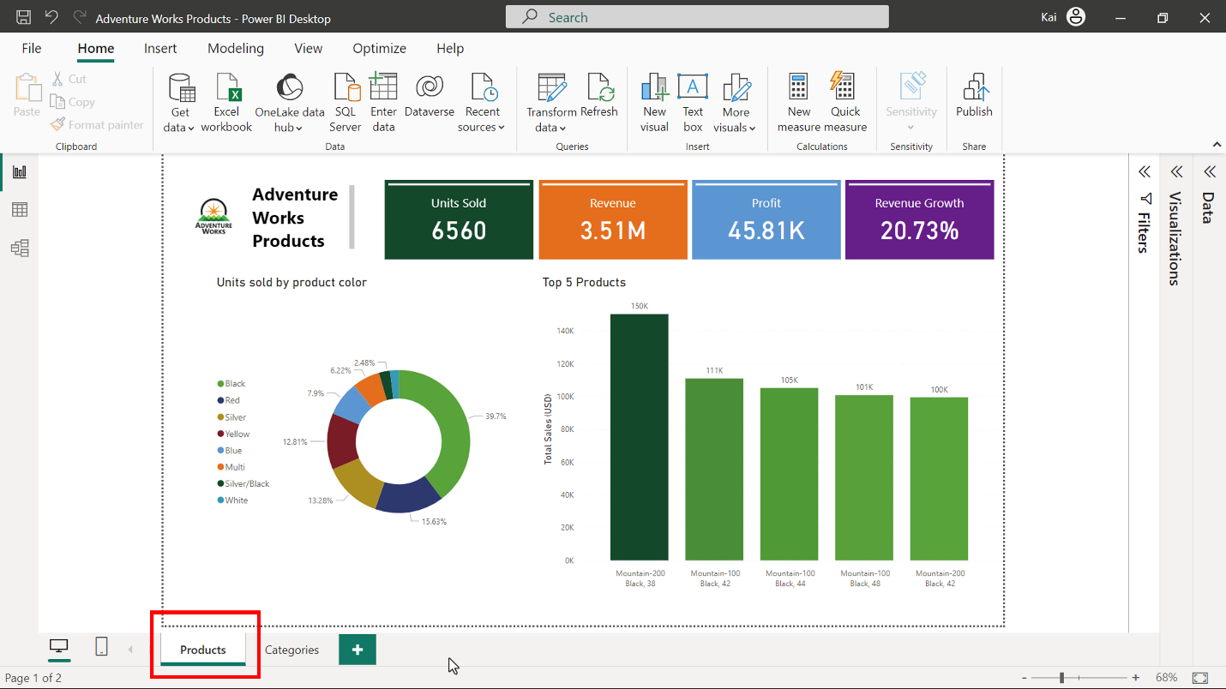

The Categories page has three visual elements; a combo chart displaying total sales and profit by product category, a bar chart representing sales by subcategories, and a table visual showing sales and units sold for each product. The entirety of information on both pages relates to products.

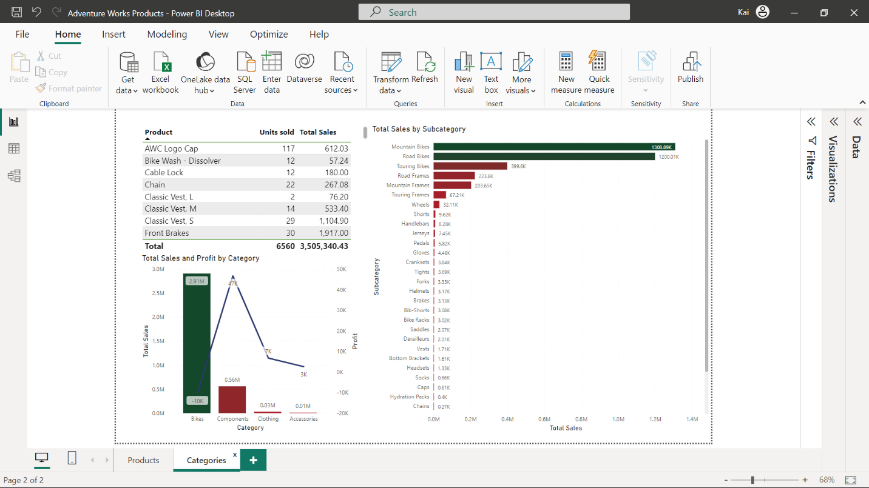

The card visuals contain the most valuable information, and the top 5 products provide insight into the top performing products of Adventure Works. You need to keep this in mind while designing a dashboard in Power BI service.

The table visual contains information about sales of each product in all regions and for the entire period of the current dataset. This is not a suitable visual element for mobile devices because users cannot scroll down the table to visualize the sales values of all products.

**Step 3: Publish the report to Power BI service and create a dashboard.**

1. Having reviewed your report, you need to navigate to the **Home** tab of Power BI desktop and select **Publish** to publish to Power BI service. You need to make sure the project is saved on your computer and all changes are saved before publishing.

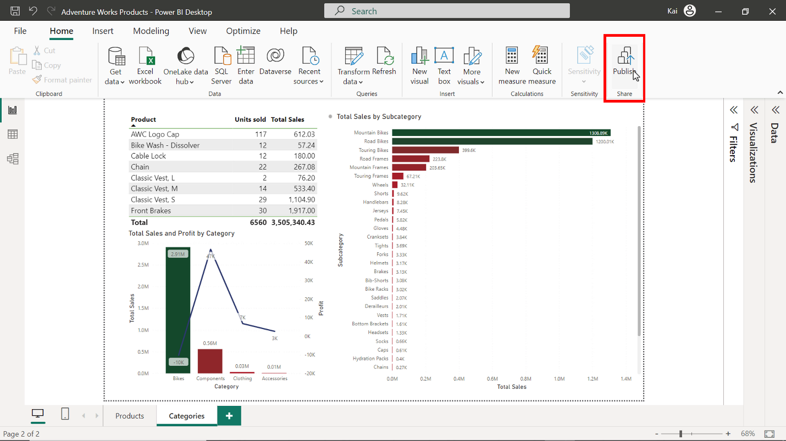

Once you select **Publish**, the **Publish to Power BI** dialog appears on screen where you need to select the workspace where you want to publish your report. Select **My workspace** and choose **Select**.

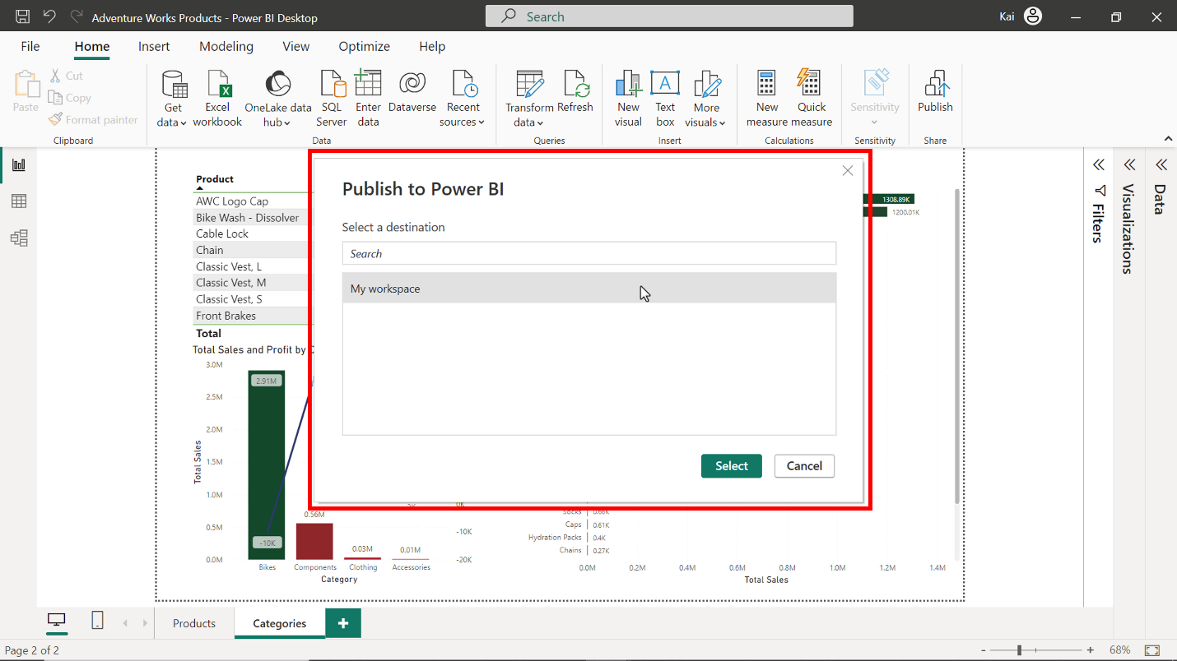

The dialog changes, and a **Success** message appears. Select **Got it**.

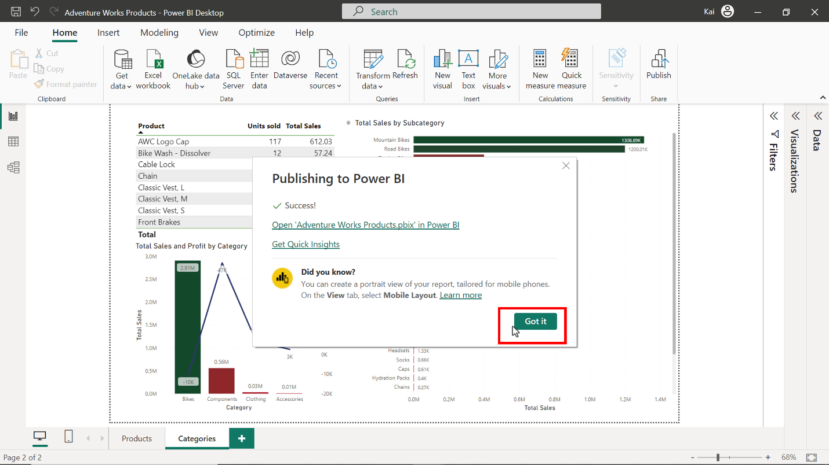

1. Open a browser and log in to your Power BI account. In Power BI service navigate to **My workspace** from the left bar of interface. You can see Adventure Works Products report is published and appears in the list.

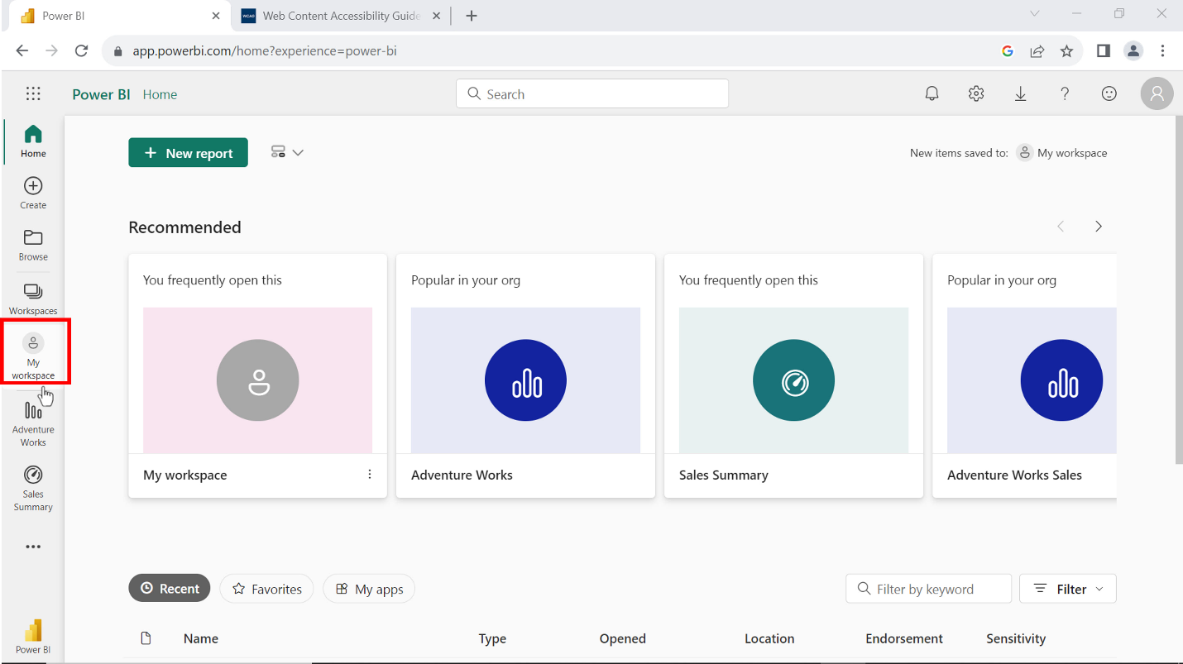

1. You need to create a new dashboard by selecting **New** from the My workspace interface and name it **Product Sales**.

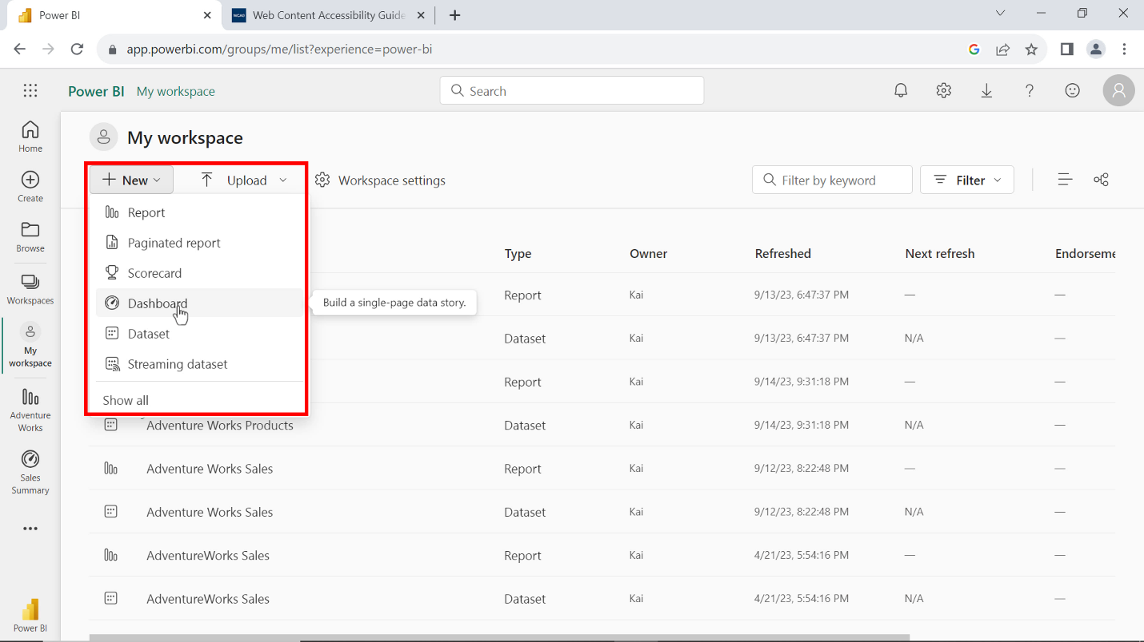

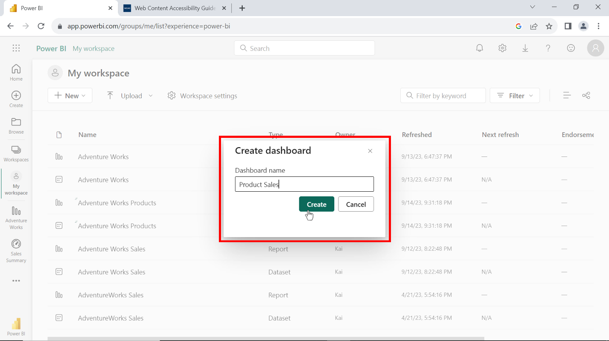

1. You need to pin all tiles from the product page of the Power BI report to the dashboard. To do this, go back to your report and select the **Product** page from the left pane. This opens the product report page.

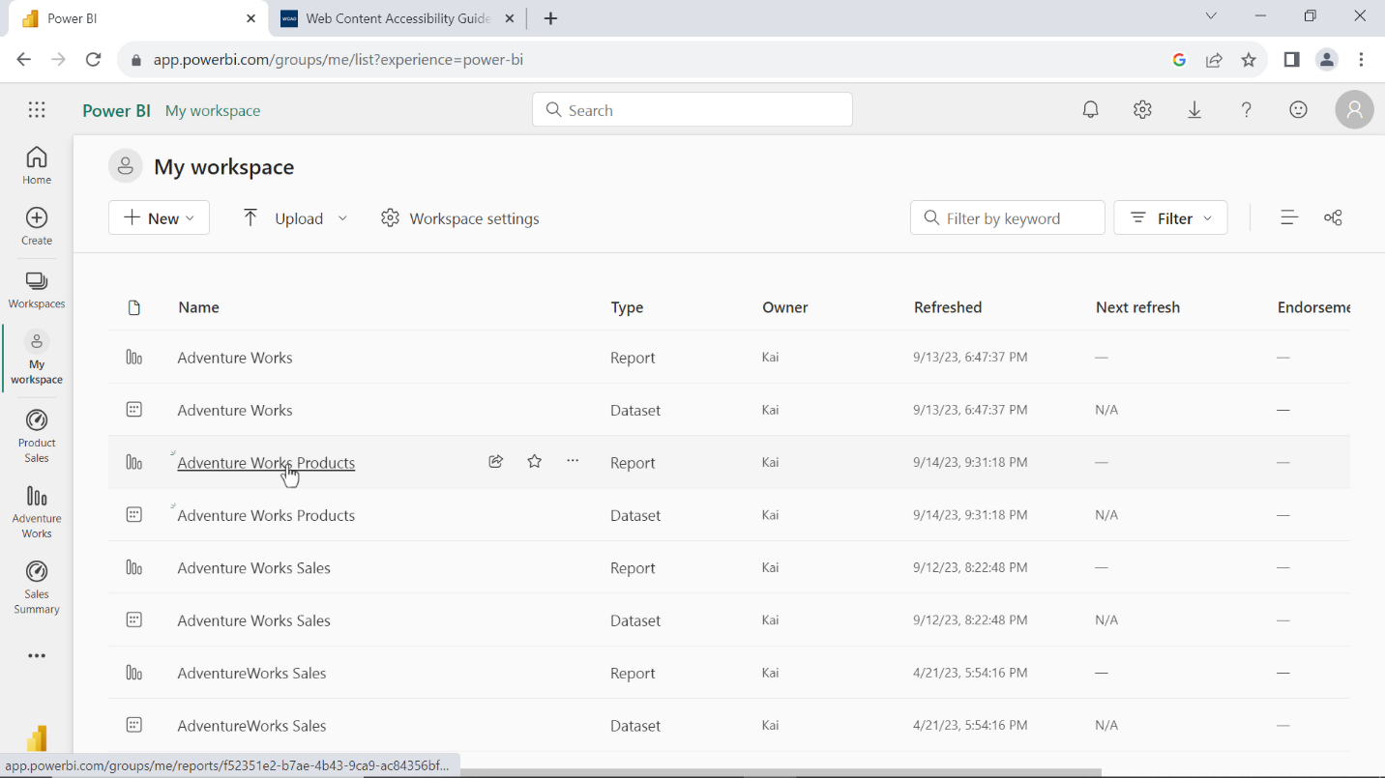

Hover the cursor on the first card visual and select the pin icon to pin the visual to the dashboard. A pin to dashboard dialog appears where you need to select the dashboard from the drop-down list where you want to pin the visual. You need to select **Product Sales** and select **Pin**. Repeat the process for all other visuals in the report page.

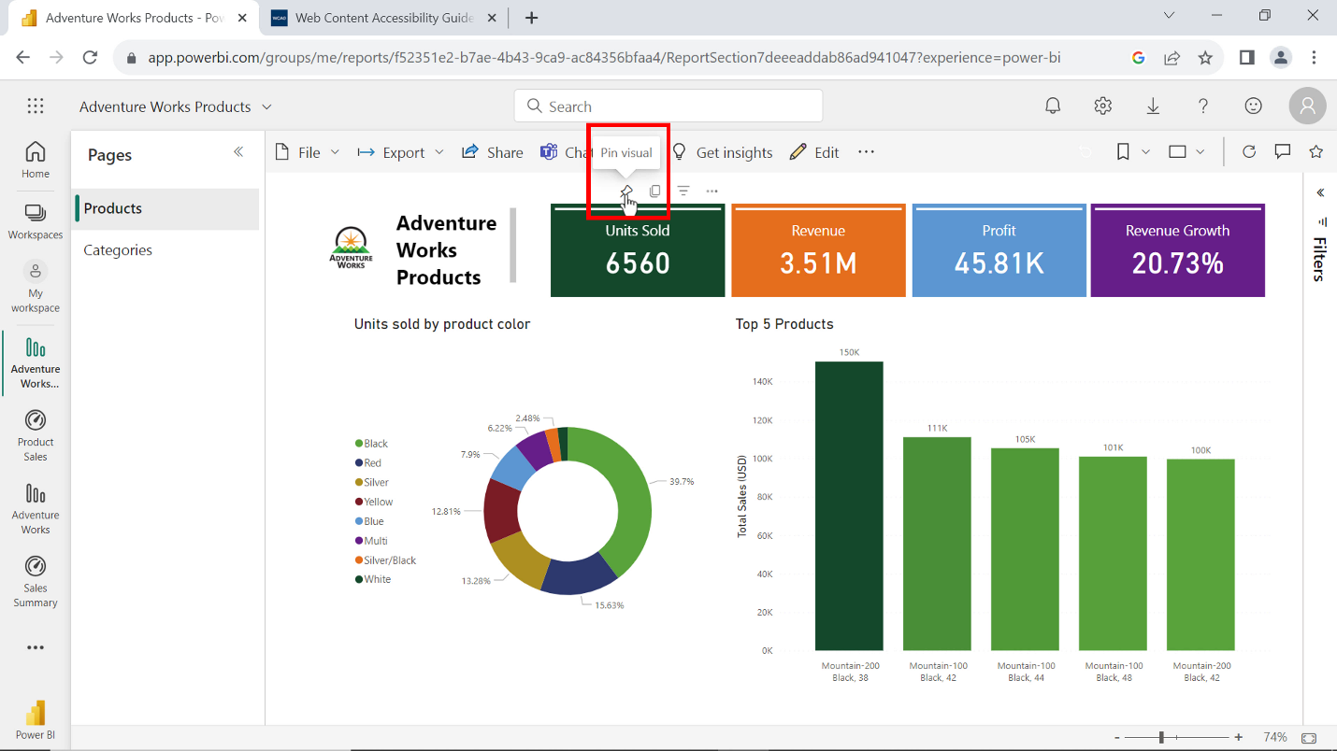

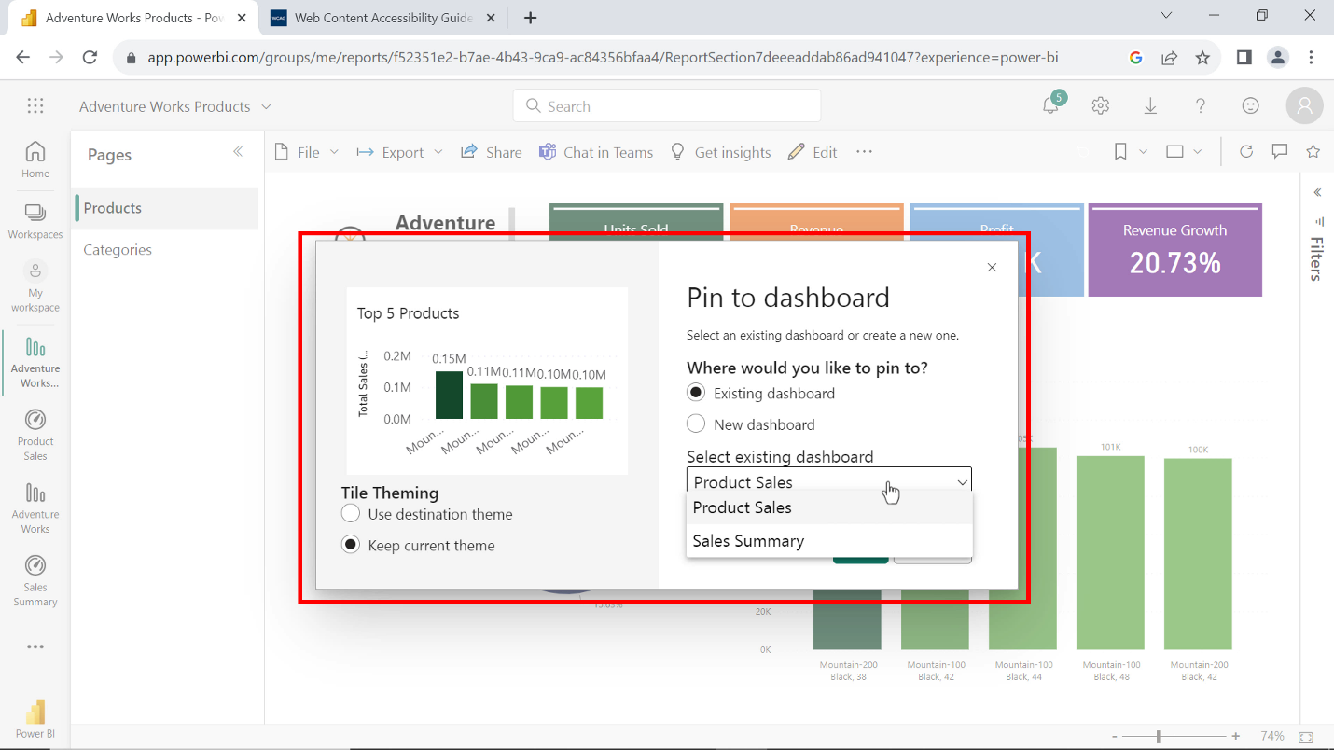

1. Pin all tiles from the categories page of the Power BI report to the **Product Sales** dashboard.

**Step 4: Optimize the dashboard for mobile devices.**

1. You need to open the **Product Sales** dashboard and navigate to edit the menu, select **Mobile layout** from the drop-down list of options. An edit mobile layout screen opens with unpinned visuals pane on the right side.

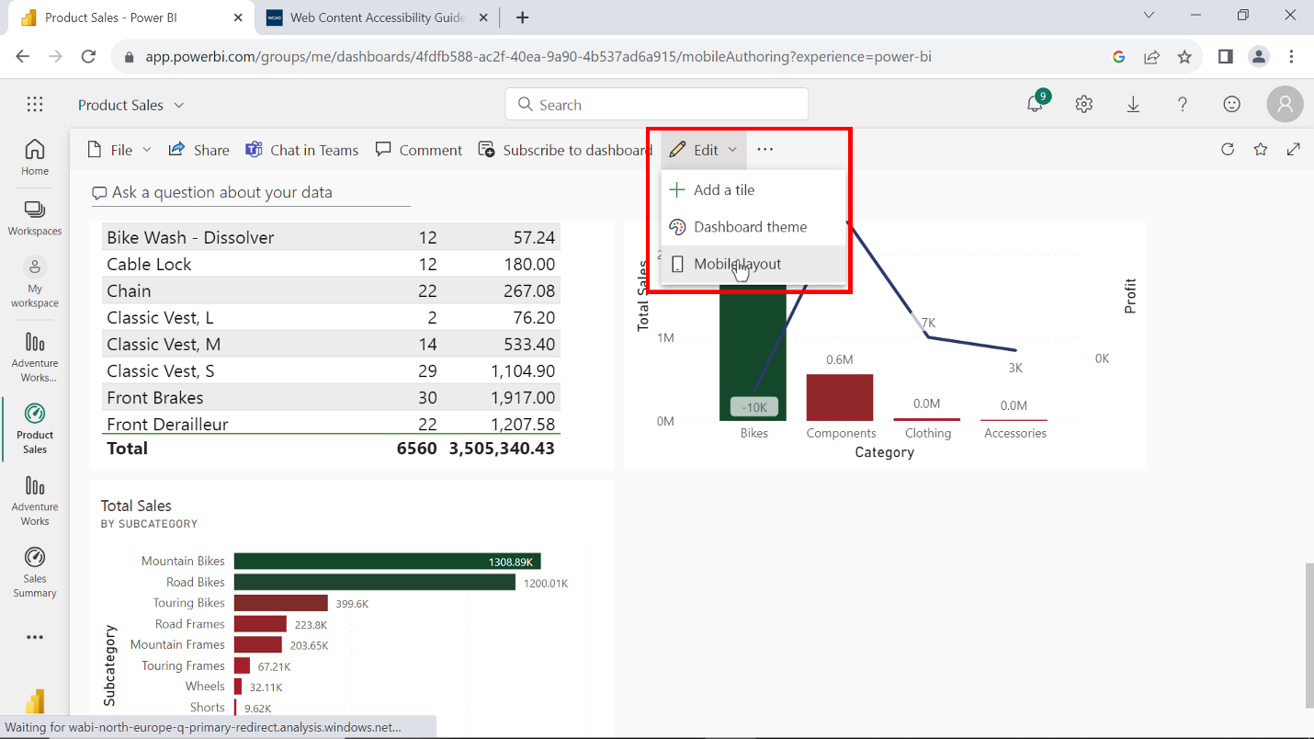

1. All the tiles from the dashboard automatically appear in mobile layout. The visual elements are not in the correct order. You can drag and reposition each tile individually to meet your needs.

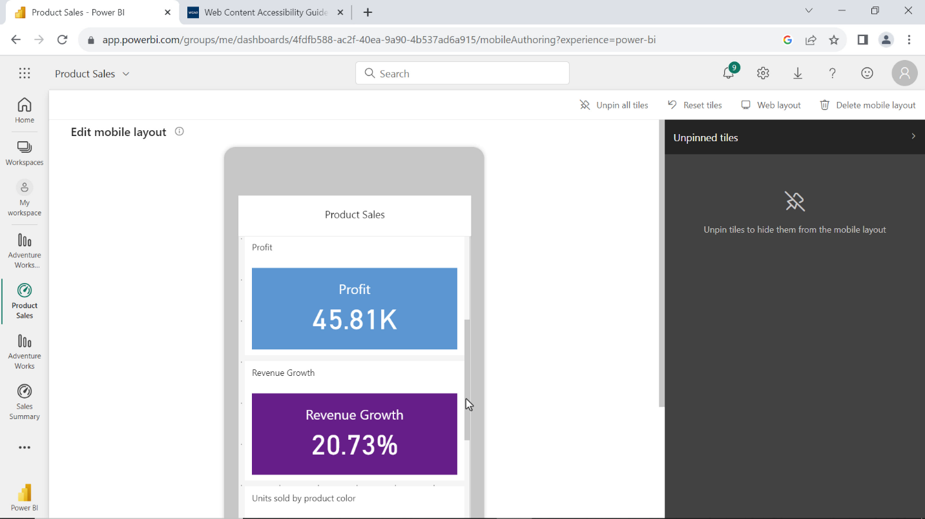

Alternatively, you can clean the entire mobile screen by selecting unpin all tiles from the top menu and then pin individual tiles in a sequence to tell a story.

1. Once you have pinned all tiles you can further reduce or enlarge the tile size and rearrange the tiles according to the narrative of the data you are presenting. For example, card visuals with snapshots of essential information should come at the top followed by the chart showing information about the top 5 products.

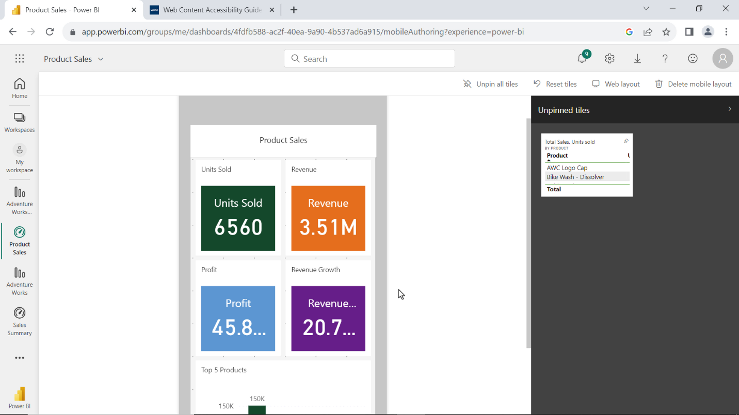

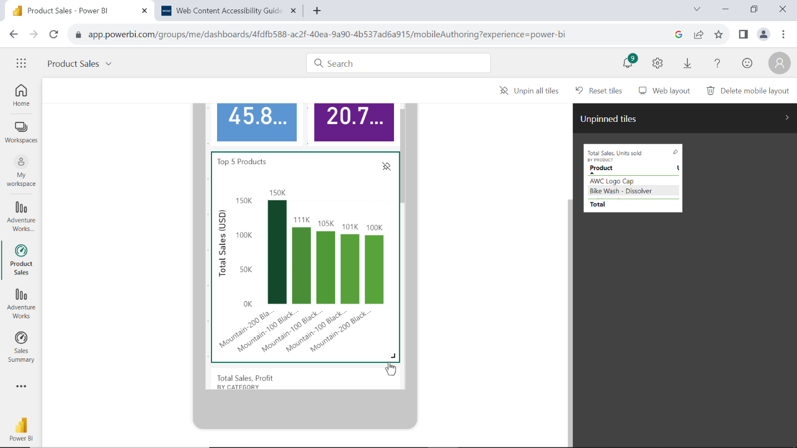

You can arrange the remaining tiles showing sales of categories, subcategories, and colors at the end of the dashboard.

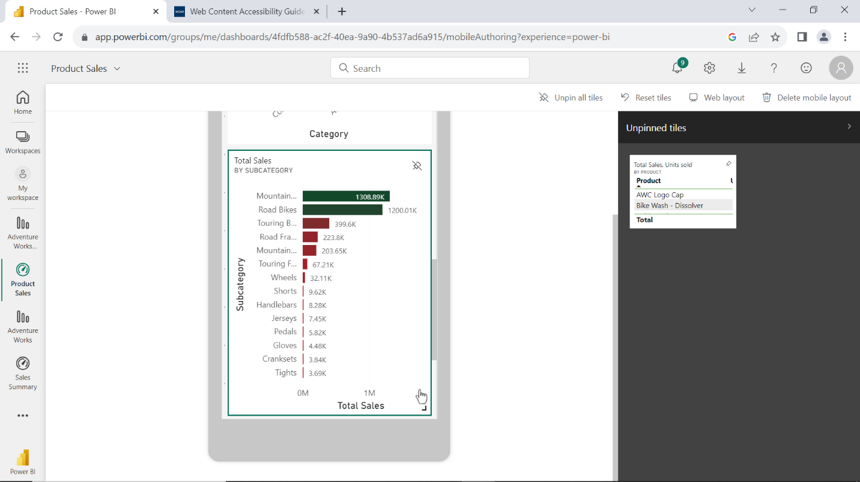

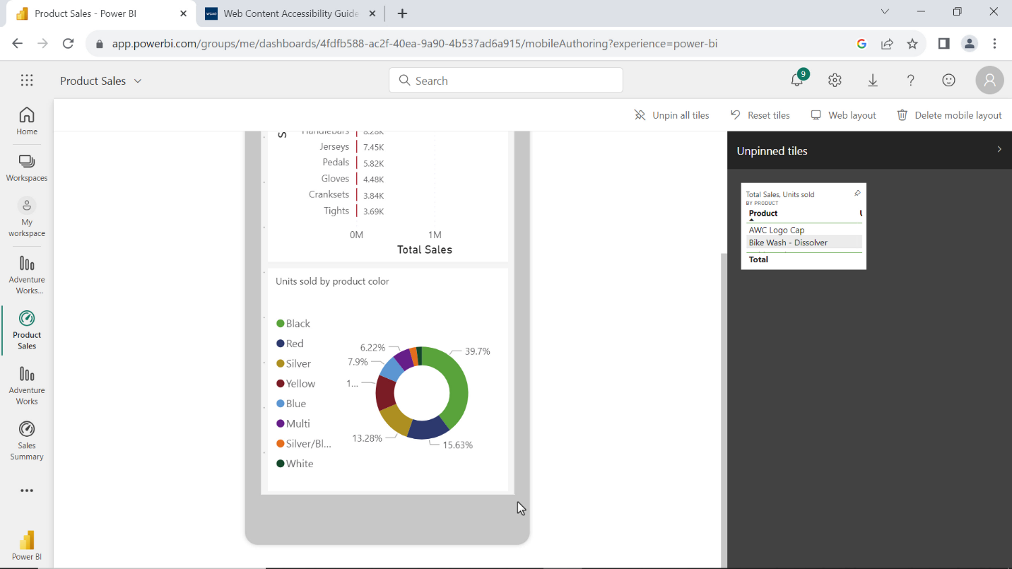

You can unpin the table visual because this information is needed for detailed reports and not a suitable visual for mobile devices.

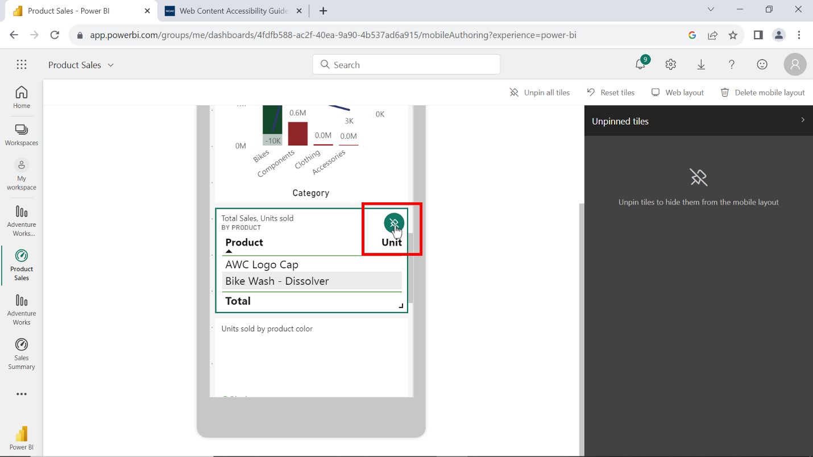

Once done, you can select web layout from the top menu to go back to desktop version of dashboard. Power BI automatically saves the mobile version. You can access the mobile version of dashboard from your cellphone. You need to download and install the Power BI mobile app and log in to access your workspace and all reports, datasets, and dashboards.

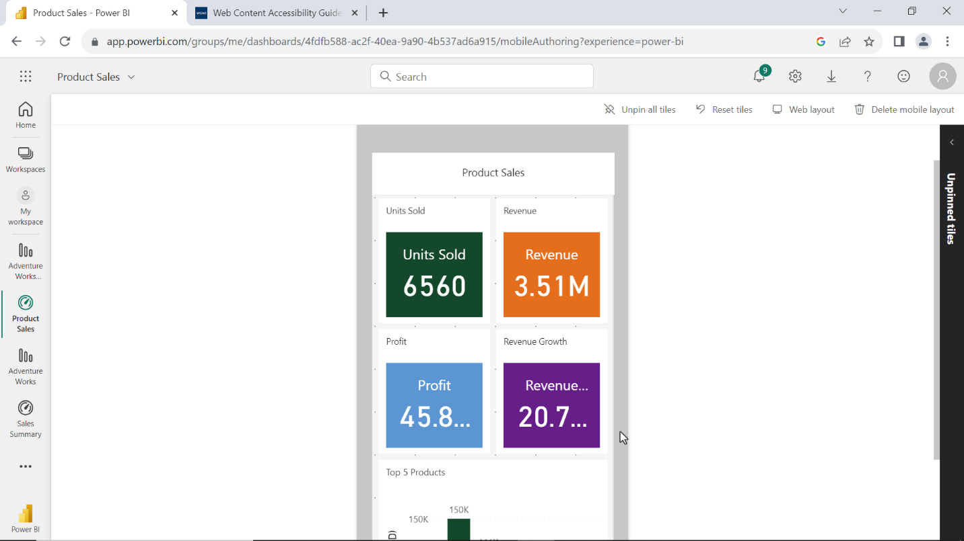

**Step 5: Save the Power BI project.**

* Save your Power BI project to your local computer.

**Tip:** Make sure you select an appropriate project name and folder path for your project.

**Conclusion**

You have successfully published a report on Power BI service, created and optimized a dashboard for mobile accessibility. Optimizing a dashboard for mobile devices is not just a matter of adapting to smaller screens, it is about ensuring that your data-driven insights are accessible anywhere and anytime in a user-friendly and mobile friendly environment.